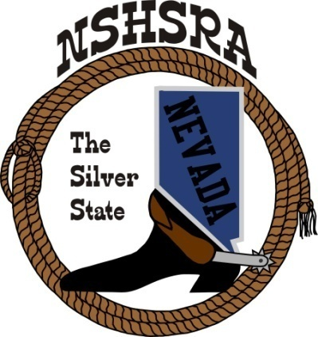
NEVADA STATE HIGH SCHOOL RODEO
STATE MEETING

6:00 pm Wednesday May 20th – Full Board

Exhibit Hall
Winnemucca, NV

AGENDA

1. Prayer and Pledge of Allegiance

2. Call meeting to order

3. a. Roll call
b. Seating of delegates
c. Installation of new clubs

4. Approval of minutes

5. Report officers
a. President
b. Vice President
c. State secretary
Online entry for JH & HS Finals
Stalls & RV for JH Nationals
RV spots for High School Nationals
Discuss updating website
d. State Treasurer

6. Report of student officers:
a. Kashlin Hill-Queen
b. Scarlett Buchanan-President
c. Brynn Barto-Vice President
d. Huntley Byrd-Secretary
e. Ryleigh Coe-Public Relations
f. Ainsley Macpherson-JHS Representative

7. National HS Director’s Report – Ron Unger

8. National JHS Director’s Report – Robert Byrd

9. Prize Committee –Sage Hiibel & Student Board
Scholarship Committee – Kathy Gonzalez
Student Advisors – Bill Process
Eligibility Committee – Kathy Gonzalez, Jessica Lancaster & TJ Shippy
By-laws Committee –Sage Hiibel, Chad Roukey and Bill Process
Crisis Fund Committee – Katie DeLong, Mindy Filippini, Carrie Eary, Jessica
Lancaster
State Finals Committee – Rose Buchnan, Jamie Noyes, Trent Whitaker, Sage Hiibel &
Student Board
Rough Stock Committee – Trent Whitaker, Jesse Segura, Justin Snow & Matt Marvel
Cutting and Cow Horse Committee – TJ Shippy, Ed Robertson

10. Old Business

11. New Business
a. Person of the Year
b. Next year’s rodeo schedule
tentative dates for rodeos:
Eureka, August 14-16
White Pine, September 11-13
Battle Mt. – no rodeo this year
Elko, October2-4
Alamo, October 23-25
Moapa, November 6-8
Pahrump, February 5-7
Las Vegas, March 5-7
Fernley, March 12-14
Washoe, March 19-21
Spanish Springs, April 2-4
Fallon, April 16-18
Humboldt, April 30-May 2
Wells, May 14-16
State Finals, May 25-31

The Executive Board is proposing to have rodeo seasons for fall and spring. The fall season will begin the 2nd weekend of August and ending the 2nd Weekend in November and the spring will begin the 2nd weekend of February and end the 2nd weekend of May. We understand that this may cause back to back rodeos, but will limit the entire season to eight months excluding state finals and nationals.

c. State Finals Help – job list
d. Director involvement in state finals. Now that the state board of directors is hosting the state finals, we need all directors or minimum of 1 director from each club to stay and help host the rodeo for its entirety. If neither director is able to stay, those positions must be proxied out.
e. State finals practices – are these important enough to have a contractor provide them, the state should be willing to ensure the contractor makes money to make it feasible. Anything over expenses, we will split 50/50.
f. Nomination and Seating of New Officers
1. President
2. Vice President
3. Northern Rep
4. Central Rep
5. Southern Rep
g. NHSRA Mandatory events – Cutting, Reined Cow Horse, JH Bareback, JH Saddle
Bronc, points system, shooting events
h. Queens titles – the Executive board would like to discuss the by law regarding any other titles being held. We would like to allow the queens to run for additional titles as long as at the high school rodeos, they only represent NSHSRA.
i. Shooting committee – trap, Beau Buchanan & rifle, Chris Christian
j. State box of supplies. The state association is spending upward of $2000 by providing supplies to clubs for their rodeos. We like to help putting on the rodeos, but it should not be the state’s financial responsibility to supply things other than the barrier and barrier supplies and labor to put up and take down.

12. Good of the Association

