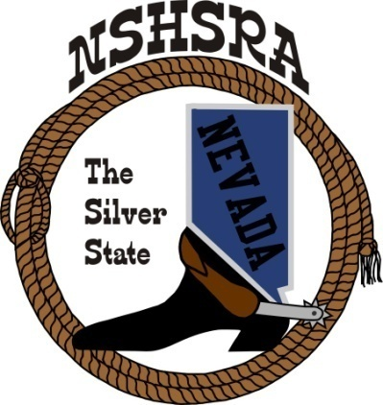
NEVADA STATE HIGH SCHOOL RODEO
MID WINTER MEETING

Bob Rudd Community Center
Corner of Hwy 160 & Basin
Pahrump, NV
Friday, February 6, 2026
9:00 a.m. – Executive Board
5:00 p.m. Full Board

Prayer/Pledge of Allegiance was said

The meeting was called to order at 9:32

Roll call was taken and present were TJ, Bob Byrd, Jessica Lancaster, Nora Lee and Scarlett Buchanan

Absent was Ron Unger, Shawn Silva, Chris Christian and Darrel Mose.

Approval of Fall Meeting minutes
Bob made the motion and Jessica 2nd to approve the fall minutes. The motion passed.

Stock Contractor bids for state finals.
All bids will be in a mailed and sealed envelope to be opened, read, and wrote down on a whiteboard for all board members to read and review. We will then discuss each contractor to ensure they have met all our bid requests and have the quality of stock we are asking for. After all discussions have been had, we will proceed to voting.

TJ discussed how we want to vote. The envelopes will be opened; we will write the company and the amount on a white board and then vote. If they are close, we will vote again on the top 2.

The Board agreed.

Also, the committee decided to combine the high school and jr. high breakaway calves, the high school and jr. high team roping steers and the high school and jr. high ribbon roping calves because of the numbers. TJ asked Kathy to forward that updated bid to the full board.

Scholarship Dinner at State Finals.
I would like to propose that the Dinner held each year be changed from a Scholarship Dinner to a Continued Education Dinner. As of now, we have 2 Scholarship programs. The main scholarship program is held at the National level and requires an application by each senior that applies and attends the National Finals and is only paid out after a college acceptance letter. The second is the senior dinner held each year during the State Finals. I would like to address that some of our seniors may not be attending a traditional 4-year college and choose to go into other fields such as truck driving, horse training, horse shoeing, cosmetology and silversmith schools. These are just a few examples that I can think of that would require additional schooling and may not be considered colleges. However, I feel that any form of continued education where they will be in a training or learning format with a signed letter from said program or business owner ensuring they will be working for or enrolled in a program is very much a form of continued education and should be allowed to get assistance from the senior dinner. I don’t feel that it is fair to discredit our seniors for not attending traditional schools. This will still require an application along with a signed letter to receive the funds from the dinner. I would also like to propose that each year of High School Rodeo acquires 25% of the dinner funds. 1 year 25%, 2 years 50%, 3 years 75%, 4 years 100%.

He went over his idea and talked about renaming it the Senior Dinner, not the Senior Scholarship Dinner. Their will be 2 separate applications, 1 for those that are attending college and one for those that will be attending a trade school, cosmetology school, lineman program, working for a trainer, etc. The kids will have to provide a letter from what ever program they will be attending in order to claim the amount they received from the dinner in order to receive it.

The board agreed with this proposal.

Mandatory Decisions for upcoming seasons
Each year we are required to vote as a full board on what is mandatory for rodeo clubs to host; Cutting, Reined Cow horse, Jr High Bear back and Jr High Saddle bronc. Also, shooting points and total carry points into State Finals based on qty of rodeos for accumulation totals. This has been happening at the Fall meeting before the first rodeo. I would like to have this vote and discussion moved up to the State Finals rodeo meeting. If any changes have been made to these requirements, it will allow for additional time for the clubs to make necessary changes to their rodeo plans.

TJ went over this item and felt that we would be better off to decide these options as the state meeting so clubs could decide what events they wanted to do.
The board agreed.

Board member on Student board
I would like to add an E-board or Full board member to the student board each year to assist the students with planning and coordination of fund raisers and activity planning. In the past, it has usually just been a parent of one of the officers. However, I feel we need to have a Board member in this position outside of the prize committee

The board had a discussion on this item and TJ explained that the student board needed help and had no adult to ask about things they wanted to do and what was expected of them.

Scarlett said she was working on board position descriptions so kids know what was expected of them.

New ground rules to adopt from national office
Bob didn’t have his paperwork with him as Ron was absent. Said he would at the full board meeting.

Good of the Association
Scarlett said that the student board wanted to make a rule that the kids running for office needed to attend at least 6 rodeos for them to be able to be officers. This would start next year as we are already half way through our season.

With nothing further to discuss, the meeting was adjourned at 10:45 a.m.

