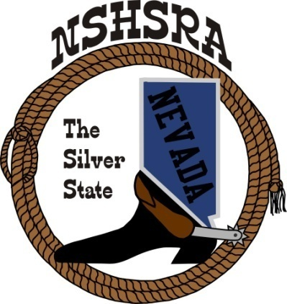
NEVADA STATE HIGH SCHOOL RODEO
MID WINTER MEETING

Bob Rudd Community Center
Corner of Hwy 160 & Basin
Pahrump, NV
Friday, February 6, 2026
9:00 a.m. – Executive Board
5:00 p.m. Full Board

AGENDA

1. Prayer/Pledge of Allegiance

2. Call meeting to order

3. Roll call

4. Approval of Fall Meeting minutes

- Stock Contractor bids for state finals.
All bids will be in a mailed and sealed envelope to be opened, read, and wrote down on a whiteboard for all board members to read and review. We will then discuss each contractor to ensure they have met all our bid requests and have the quality of stock we are asking for. After all discussions have been had, we will proceed to voting.

- Scholarship Dinner at State Finals.
I would like to propose that the Dinner held each year be changed from a Scholarship Dinner to a Continued Education Dinner. As of now, we have 2 Scholarship programs. The main scholarship program is held at the National level and requires an application by each senior that applies and attends the National Finals and is only paid out after a college acceptance letter. The second is the senior dinner held each year during the State Finals. I would like to address that some of our seniors may not be attending a traditional 4-year college and choose to go into other fields such as truck driving, horse training, horse shoeing, cosmetology and silversmith schools. These are just a few examples that I can think of that would require additional schooling and may not be considered colleges. However, I feel that any form of continued education where they will be in a training or learning format with a signed letter from said program or business owner ensuring they will be working for or enrolled in a program is very much a form of continued education and should be allowed to get assistance from the senior dinner. I don’t feel that it is fair to discredit our seniors for not attending traditional schools. This will still require an application along with a signed letter to receive the funds from the dinner. I would also like to propose that each year of High School Rodeo acquires 25% of the dinner funds. 1 year 25%, 2 years 50%, 3 years 75%, 4 years 100%.

- Mandatory Decisions for upcoming seasons
Each year we are required to vote as a full board on what is mandatory for rodeo clubs to host; Cutting, Reined Cow horse, Jr High Bear back and Jr High Saddle bronc. Also, shooting points and total carry points into State Finals based on qty of rodeos for accumulation totals. This has been happening at the Fall meeting before the first rodeo. I would like to have this vote and discussion moved up to the State Finals rodeo meeting. If any changes have been made to these requirements, it will allow for additional time for the clubs to make necessary changes to their rodeo plans.

- Board member on Student board
I would like to add an E-board or Full board member to the student board each year to assist the students with planning and coordination of fund raisers and activity planning. In the past, it has usually just been a parent of one of the officers. However, I feel we need to have a Board member in this position outside of the prize committee

- New ground rules to adopt from national office

13. Good of the Association

