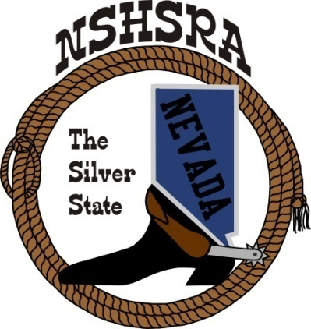**NEVADA STATE HIGH SCHOOL RODEO**

**FALL MEETING**

**Thursday, August 14th at 6:00 pm – Executive Board**

**Friday, August 15th at8:00 am – Full Board**

**Eureka County Fairgrounds**

**Eureka, NV 89316**

**AGENDA**

Pledge of Allegiance

Call meeting to order

Roll call

a. Seating of delegates

b. Installation of new clubs

Approval of minutes from state meeting in May

Report of officers

1. President
2. Vice President
3. State Secretary
4. State Treasurer/report from state finals

Report of student officers:

a. Kashlin Hill-Queen

b. Scarlett Buchanan-President

c. Brynn Barto -Vice President

d. Huntley Byrd-Secretary

e. Ryliegh Coe-Public Relations

f. Ainsley Macpherson-JHS Representative

National HS Director’s Report

National JHS Director’s Report

Committee appointments

a. Prize committee appointments

b. Scholarship committee

c. Points committee

d. Queen committee

To discuss the appointment of a new queen director.

e. Student Advisory committee

f. Eligibility committee

g. Bylaws committee

Bylaws review. Discussion of the Current Bylaws and the necessity to have them rewritten or are they ok in their current state.

If the board votes to change the reading of the Bylaws the E-Board will choose an attorney to work directly with the E- Board and Bylaws committee to ensure all changes are binding and legal with current laws

New committees to be appointed:

Rodeo assistance committee:

This committee will handle care packages for all districts putting on a rodeo in the fall or spring season. This will include arena directors, flaggers, timers, gate openers, tractor drivers, all in the local area. If no one is available on the list given, then assist in finding help. Provide training or assistance with rules and bylaws for directors and flaggers before the rodeo begins if needed. .

State rodeo committee:

This committee is to work directly with the E-Board to put together bid packages for all bidders to include the following; the number of stock needed for each event Junior High and High School; figure out hay needs for stock and try to find hay donations; find arena directors, flaggers, all assisting positions for each performance, timers, announcers, office help and scheduling.

Bylaws and rules committee:

To Work with E board and directors to ensure all rules are to be followed throughout each season. Help train our arena directors, flaggers, and timers to ensure they are willing, and capable of helping out at our rodeos throughout each season. Reviewing any changes presented by the E board or full board to make sure no rulings are made incorrectly. Helping with any grievances  throughout the season to make sure our rodeo officials are both backed in their rulings, and corrected if such event has occurred. Update all ground rules through each rodeo season.

Rough stock committee

To ensure we are providing the best stock we can get for our rough stock contestants. Work with each rodeo as needed for judges and stock overview. Help the state committee with procuring the best animals for our athletes’ abilities at our state finals rodeo

When the rough stock and queen committees have been assigned new directors, there will be a ground rule allowing those directors to go out of the full board and find professionals in this field and allow them to assist in the running of those committees.

Old Business

1. Confirm 2025-26 rodeo schedule

New Business

1. Cutting, reining, bareback and saddle bronc steer riding , optional or mandatory
2. Shooting points to accumulate during season or qualify top 4 at state finals
3. Set dues. Current: Students: $26 Independent: $276 clubs: $200
4. Set assessments for 24-25 ($5 fee from rodeos that is split into general/scholarship/crisis fund)
5. Host club for Cowboy Prom
6. Point system
7. Presentation of rough stock issues given by Trent Whitaker along with rough stock contestants to address full board with their thoughts on how to improve our rough stock events and contestant opportunities throughout our rodeo seasons to ensure we are working towards a better future for all contestants in these events.
8. Bids for State Rodeo. To discuss the following issues such as allowing contractors to bid on their best fit, rough stock, timed events, allowing them to bid on only their best animals in each event. How to ensure we are getting the best stock for our contestants to showcase their abilities in each of these events. Are we making sure that our insurance can cover multiple stock contractors providing stock to our awarded contractor.

Good of the Association

Adjournment