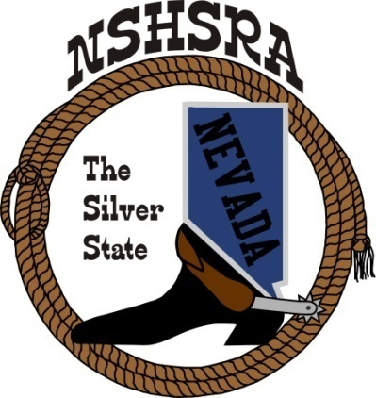**NEVADA STATE HIGH SCHOOL RODEO**

**FALL MEETING**

**Thursday, August, 14th at 6:00 pm – Executive Board**

**Friday, August 15th at 8:00 am – Full Board**

**Eureka County Fairgrounds**

**Eureka, NV**

**AGENDA**

Pledge of Allegiance

Call to order

Roll call

Minutes of previous meetings

Gatlin Sleppy infraction at nationals

Daxton Melindez infraction at nationals.

Should we ask both young men to write letters about what happened how it happened and what made them decide to act in the manner, or should we make them both attend the fall meeting to discuss the situation in person. I know Dax wasn’t really involved however we still need to discuss it to ensure transparency throughout

State Finals Review

State rodeo review. Did we miss anything at our first meeting that needed addressed. I feel each club should be asked to help with events. No director should be without a position at state

Bids for state rodeo

To discuss the following issues such as allowing contractors to bid on their best fit, rough stock, timed events, allowing them to bid on only their best animals in each event. How to ensure we are getting the best stock for our contestants to showcase their abilities in each of these events. Are we making sure that our insurance is able to cover multiple stock contractors providing stock to our awarded contractor

By-laws review

Bylaws review. I feel it be best for the association to have an overview of the bylaws by an attorney chosen by the E-Board or full board to ensure we are doing the best for the association. It’s has been brought to my attention that these should only be handled by an attorney and not our parents for any necessary changes to the reading of the bylaws and then voted into law by full board. We can work with our attorney to ensure we are getting it correct however we are making the association extremely vulnerable by not having this handled properly

Presentation of rough stock issues that have been continuously brought to my attention. I have asked Trent Whitacker along with rough stock contestants to address the E- board with their thoughts on how to improve our rough stock events and contestant opportunities throughout our rodeo seasons to ensure we are working towards a better future for all contestants in these events.

Queen committee. I would like to discuss the appointment of a new queen director as the current coordinator is no longer a director of the Washoe club. Also discuss how to properly handle the day-to-day issues of appearances of our queens and how to properly address our flow of communication

New committees. Discuss the following committees to decide if they are needed or add value to the association.

State rodeo to handle all aspects of the state finals including bidding and event coordination.

State rodeo activities

Rough stock

By laws training for new arena directors

Laurel Thomas. Should we appoint Laurel to all boards that are spending money for the association. I strongly feel that she should be added to all these committees. Not to make decisions, however to ensure that all our money is accounted for and offer advice as needed

Kathy Gonzales. I would like to discuss the position of secretary and the duties that follow. I feel that a lot has been added to Kathy’s plate over the many years of her service and I would like to talk with her about those added positions and if we able to have some of those jobs can be delegated to other board members. Also discuss online entries progress and what we can do to help.

Scholarship committee. I would like to address several items in this area as I feel we are not the police but should have a follow up with all our seniors. Especially if we have several committee members we should appoint one strictly to follow up on applications. Should we as an association demand all our seniors attend college to get the money from the senior dinner or share the money equally as long they meet the requirements excluding college. For example, we have 2 young women who worked hard for each year beginning in 5th grade through high school who choose horse training as their college and career who never received any money for the dinner they helped put on and attended. We should not punish kids who choose not to go to college, we should be willing to assist them in any way possible in their future endeavors in my opinion

New ground rules to adopt from the national office

Points system

Good of the Association

Adjournment