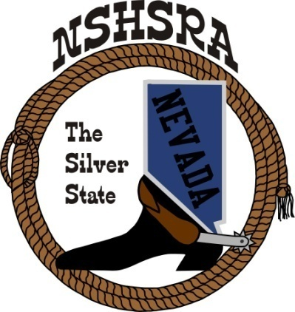
NEVADA STATE HIGH SCHOOL RODEO
MID WINTER MEETING

6:00 p.m. – Executive Board
9:00 a.m. Full Board

Tonopah, NV

Friday, January 21, 2025

- Pledge of Allegiance

- Call meeting to order

- Roll call

- Approval of previous minutes

- HS National Director

- Jr. High National Director

- State Help - Arena Director’s, Judge’s, Flagger’s

- Treasurer position

- State Schedule

- Good of the Association

